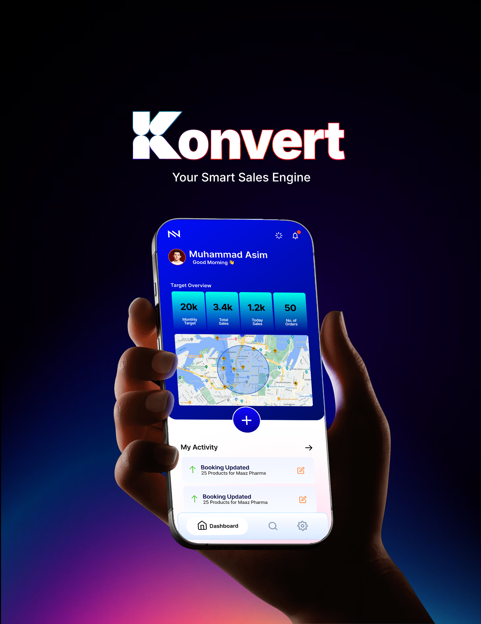



A sales management and tracking ecosystem built to run multi-tier sales hierarchies, simplify distribution workflows, and give Pakistani businesses a secure, localized alternative for data-driven decision-making

Founding Team:
Almashreq Soft

Prepared For:
Prospective Clients




Summary

Konvert is a sales operations system that runs your entire field force — from the sales rep and MRs on the ground up to the National Sales Manager — all on one platform. No matter how many layers your team has, everyone sees the same accurate, up-to-date information at the same time.
It tracks visits and routes in real time, automates sales tasks like tour planning, logging, and reporting, and gives managers a clear, live picture of what's happening in the field instead of using pen and paper. It's built to scale with your business, whether you're a small team or a large enterprise, with one simple goal: help you get more return from what you're already spending on sales operations.

Table of Contents
Introduction 5
Konvert Overview 5
Core Features & Capabilities 6
Platform Structure 7
Organizational Hierarchy (Organogram) 8
Features 9
User & Organizational Hierarchy Management 9
Territory & Route Management 10
Customer Database (Master Data) 10
Monthly Visit Planning 11
Daily Call Reporting & Field Visits 11
Sample & Promotional Material Management 12
Order Management & Retail Sales 12
Travel Expenses & Attendance 13
Targets & Incentives 13
E-Detailing (Digital Presentations) 14
Reporting, Administration & Integrations 14

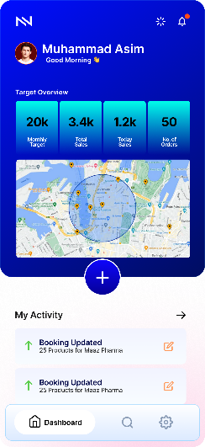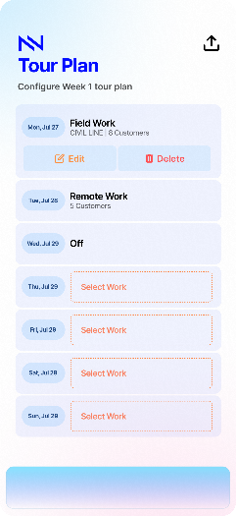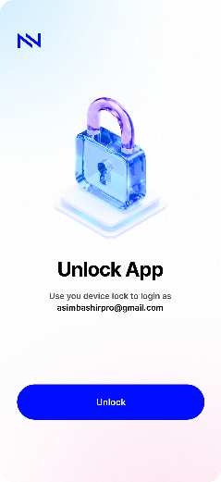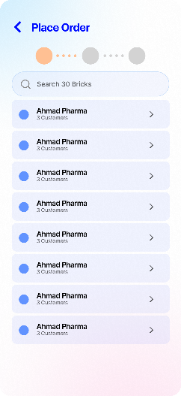

Section 1

Introduction

1.1

Konvert Overview
Konvert, developed by Almashreq Soft, is a comprehensive field force management application built specifically for pharmaceutical companies in Pakistan. The platform is designed to close the costly gap between head office sales plans and actual on-the-ground execution. By connecting medical representatives, managers, and head office into a single ecosystem, Konvert provides real-time visibility into field operations while eliminating manual, memory-based reporting.
It is positioned as a highly secure, locally priced alternative to expensive multinational systems (like Veeva) and older, easily manipulated local software.

1.2

Core Features & Capabilities
The platform operates through ten integrated modules designed to handle the daily workflow of a pharmaceutical sales team:
Monthly Tour Planning (Visit Calendar): The system let’s users build a representative's monthly visit plan to ensure high-value doctors are seen frequently enough. Representatives can review and adjust the plan, which is then sent to managers for approval before daily routes appear on the rep's phone.
Fast Visit Logging (Daily Call Report): Representatives can log a complete doctor visit—including verifying location, recording product discussions, and distributing samples—in under two minutes.
Customer & Master Data Management: Maintains a clean, shared database of all doctors, chemists, and distributors, featuring built-in checks to prevent duplicate entries when reps add new contacts.
Chemist Order Booking (Secondary Sales): Representatives can take orders directly at the chemist counter, automatically applying correct prices and discounts, and route the order straight to the distributor. This gives head office real-time visibility into actual retail sales, not just warehouse dispatch numbers.
Sample Record-Keeping (DRAP Compliance): Tracks medical samples from the warehouse down to the exact doctor, checking batch numbers and expiry dates to ensure compliance with Drug Regulatory Authority of Pakistan (DRAP) audit rules.
Automated Expense Claims: The system calculates travel distances automatically using the representative's verified daily GPS records. Reps attach receipt photos, and finance teams can easily spot discrepancies between claimed distances and actual GPS data.
Geo-Attendance & Communications: Daily attendance is marked automatically the moment a rep completes their first verified visit. The app also includes a team messaging system with read receipts, ensuring official head office communications are seen.
Targets & Incentive Tracking: Reps can view their sales targets, track their daily progress, and see estimated bonus payouts and team leaderboards directly on their phones.
Digital Presentations (e-Detailing) & Alerts: Replaces paper materials with digital tablet presentations, recording exactly what the doctor viewed. The system proactively flags "at-risk" doctors whose prescribing habits are dropping so the company can intervene.
Company Structure & Territories: Head office can map out their exact organizational hierarchy (Reps → Area Managers → Regional Managers), ensuring data is secure and that staff transitions happen without losing historical records
1.3

Platform Structure
1. The Mobile App (For the Field Team)
This is the daily tool for your sales representatives, built for speed and reliability.
- Works Anywhere: It functions fully offline for up to a week, allowing representatives to access their plans, log visits, and book orders even in complete signal dead zones.
- Fast Execution: A representative can log a complete, GPS-verified doctor visit and track samples in under two minutes.

2. The Web Admin Panel (For Managers & Head Office)
This is the command center for your management team, giving Area Managers, Regional Managers, and Head Office a clear view of the field.
- Real-Time Visibility: When a representative logs a visit in the field, it appears on a manager's screen within a few minutes.
- Simplified Management: Managers use this web portal to set company hierarchies, approve monthly visit plans, monitor sales targets, and review automated travel expense claims.

3. The Secure Cloud Engine (The Backend)
Working invisibly in the background, this is the technology layer that ensures your data is secure and accurate.
- Automatic Syncing: The system automatically pushes saved data to head office the moment a representative's phone reconnects to the internet.
- Trusted Data: It runs multiple, advanced security checks to actively block fake GPS apps and manipulated locations, ensuring you can fully trust the data you use to make business decisions.

1.4

Organizational Hierarchy (Organogram)
Tier | Typical Title(s) | Typically Manages | Primary System Concern
1 | Medical/Sales Representative (MR/SR) | A named list of doctors, chemists and stockists in one territory | Execute tour plan; log DCRs, samples, orders, expenses
2 | Area Business/Sales Manager (ABM/ASM) | 3-10 MRs across an area | Approve tour plans and exceptions; monitor DCR/expense compliance
3 | Regional Sales Manager (RSM) | Multiple ABMs across a region | Regional target achievement; territory design decisions
4 | Zonal Sales Manager (ZSM) | Multiple regions across a zone (a country is typically split into 4-6 zones) | Zonal strategy; cross-region resource allocation
5 | National Sales Manager (NSM) / Sales Director | All zones | National sales strategy, incentive scheme design, board reporting

Section 2

Features

Here is a complete, client-friendly breakdown of the platform's functional requirements, separated by their specific business modules. We have focused entirely on the practical capabilities and business value of each feature, removing technical jargon and priority rankings.
2.1

User & Organizational Hierarchy Management
This module controls how your company’s structure is mapped out and ensures that data is kept secure across different management levels.
Capability | Business Value
Custom Company Structure | Configure your exact reporting lines (e.g., Representative → Area Manager → Regional Manager) to match your real-world setup.
Role-Based Security | Automatically restricts access so managers only see the data, reports, and dashboards belonging to their specific teams.
Employee Transfers | Smoothly reassign territories and customer lists when staff change roles, while keeping historical sales and visit data perfectly intact.
Secure Off-Boarding | Instantly revoke system access for departing employees and transfer their open approvals to successors.
Visual Organization Chart | Provides an interactive, visual chart of your entire sales organization that can be filtered by region and role.

2.2

Territory & Route Management
This module manages how your geographical coverage is divided and assigned to the field force.
Capability | Business Value
Territory Mapping | Break down geographical coverage from large zones down to specific recurring routes and towns.
Independent Targets | Link sales targets and doctor lists to the territory itself, ensuring that a new representative inherits them automatically.
Coverage Simulation | Test out proposed territory realignments to balance workloads before making the changes live in the field.
Map-Based Visualization | View territory boundaries and customer density visually on a map to spot gaps in coverage.

2.3

Customer Database (Master Data)
This is the central directory that powers all visits, ensuring you have a clean, duplication-free list of customers.
Capability | Business Value
Detailed Profiles | Maintain rich, centralized records for doctors, chemists, and distributors, including GPS coordinates and visit frequency rules.
Duplicate Prevention | Automatically scans for matching names and location proximity to stop representatives from adding the same doctor twice.
Manager Approvals | Requires an Area Manager to approve any new customer added by a representative before they become visible system-wide.
Full Audit Trail | Tracks every change made to a customer profile, logging exactly who changed it, what was changed, and when.

2.4

Monthly Visit Planning
This aligns the company’s visit strategy with the representative's actual daily schedule.
Capability | Business Value
Automated Planning | Auto-generates daily schedules based on a representative's standard weekly routes.
Frequency Enforcement | Blocks representatives from submitting a plan if it fails to include the minimum required visits for high-value doctors.
Holiday & Leave Sync | Automatically blocks out approved leave days and regional public holidays from the planning calendar.
Manager Review | Managers can approve plans as-is, add specific comments, or reject them with a mandatory reason.
Plan vs. Actual Tracking | Generates real-time reports comparing what the representative planned to do versus the visits they actually completed.

2.5

Daily Call Reporting & Field Visits
The core field execution tool, designed to be fast, reliable, and secure against manipulation.
Capability | Business Value
GPS-Verified Check-In | Validates the representative's location against the doctor's clinic within a strict geographical boundary.
Exception Handling | If a representative checks in outside the GPS boundary, it asks for a reason and flags it for the manager rather than blocking the work.
Offline-First Logging | Representatives can log full visits with zero internet signal; the app automatically syncs when connectivity returns.
Fast Visit Capture | Quickly record the products detailed, doctor feedback, next-step commitments, and visit duration.
Anti-Fake GPS | Automatically flags suspicious activity, such as impossible travel speeds between visits or the use of fake GPS apps.

2.6

Sample & Promotional Material Management
Bridges the gap between marketing material distribution, regulatory compliance, and actual retail sales.
Capability | Business Value
Live Sample Ledger | Tracks sample inventory for each representative, automatically deducting stock when handed out during a visit.
Reconciliation Audits | Highlights any differences between the stock issued by head office and the stock distributed, ensuring regulatory compliance.
Expiry & Batch Controls | Tracks batch numbers and expiry dates to prevent field staff from distributing expired promotional items.

2.7

Order Management & Retail Sales
Connects field representatives directly to the supply chain to capture real-time demand.
Capability | Business Value
Chemist Order Booking | Representatives can book orders directly at the pharmacy using live pricing and discounts.
Distributor Routing | Sends booked orders straight to the linked distributor with tracking for fulfillment status.
Retail Sales Visibility | Gives head office clear visibility into actual retail counter sales, not just warehouse dispatches.

2.8

Travel Expenses & Attendance
Automates administrative tasks for field staff and finance teams.
Capability | Business Value
Policy-Mapped Claims | Representatives submit travel and daily allowance claims that are strictly governed by company rules and job grades.
GPS-Calculated Fuel | Automatically suggests travel distances using the verified GPS coordinates logged between calls that day.
Multi-Tier Approvals | Routes claims seamlessly from the Area Manager up to Finance, allowing queries or rejections at each step.
Automated Attendance | Marks daily attendance automatically the moment a representative completes their first verified visit of the morning.

2.9

Targets & Incentives
Keeps the field force motivated and aligned with commercial goals.
Capability | Business Value
Live Target Tracking | Cascades sales targets so representatives and managers can see their exact progress on their phones in real time.
Bonus Estimator | Shows representatives an estimate of their incentive payouts based on their current achievements.
Leaderboards | Supports time-boxed sales contests and team leaderboards to drive performance.

2.10

E-Detailing (Digital Presentations)
Modernizes how your representatives present products to healthcare professionals.
Capability | Business Value
Digital Content Library | Head office can push approved brochures, videos, and sales materials directly to representative devices.
Engagement Tracking | Logs exactly which presentation slides a doctor viewed and for how long, saving the data straight to the visit report.

2.11

Reporting, Administration & Integrations
The backend tools required to monitor the business, adjust rules, and connect to other software.
Capability | Business Value
Role-Scoped Dashboards | Pre-built dashboards for compliance, coverage, and sales, customized for each management tier.
Custom Report Builder | Allows head office to build custom reports with specific filters and export them to PDF or Excel.
Master Control Panel | Allows administrators to change business rules (like GPS boundaries or expense policies) without needing software updates.
System Integrations | Connects with your existing HR systems, ERPs, BI tools, and provides hooks for tax e-invoicing.
Broadcast Messages | Head office can send official circulars and announcements to the field team with verifiable read-receipts.

